|  |
| --- |
| CONCUR TRAVEL & EXPENSE USER GUIDE |
| A picture containing person, man  Description generated with very high confidence |

Table of Contents

Document Control 3

Document History 3

Introduction 4

Welcome to Concur Traval and Expense Solution for Zensar 5

Signing in to Concur Travel and Expense Solution 5

Retrieving and Changing your Password 6

Travel and Expense 8

Updating Your Profile 9

Acting as a Request Delegate/Expense Delegate 11

Concur Request 12

Air Ticket 16

Hotel Booking 17

Railway Booking 17

Cab Booking / Car Rental 18

Dependents/family or Guest booking 19

Approver Flow 20

Audit Trail 21

Manager Approval Screen 22

Creating an Expense Report 25

Printing and Submitting an Expense Report 30

To preview and print the expense report 30

User Support Desk International Toll Free Service (ITFS) for Concur 32

# Document Control

|  |  |  |
| --- | --- | --- |
| **Author** | **Reviewer (s)** | **Authorizer** |
| Sanjeev Tomar | Ankush Akar | Ankush Akar |
|  |  |  |

# Document History

|  |  |  |  |
| --- | --- | --- | --- |
| **Date** | **Author** | **Version** | **Change** |
| 07-Dec-18 | Sanjeev Tomar | 1.0 | Initial Version |
| 10-Dec-18 | Sanjeev Tomar | 1.1 | Added Toll free information |
|  |  |  |  |

# Introduction

Concur's Travel & Expense Management Solution helps you Zensar Associates manage the Corporate travel booking process from beginning to end. It can be used by itself or integrated with expense tracking. Together they make up a single service that helps you save time and improve control.

As you book your travel Concur accesses your profile and searches for criteria through global distribution systems, direct connect providers, and the web. You'll see all the results that meet your criteria, as well as additional choices that fit within Zensar corporate policy.Associates can quickly and easily modify the search, sliders and drop down lists help you adjust time frames as you request flights, rail or bus, and visual cues help ensure you adhere to company policy.

It's easy to find a hotel. Find one based on distance from the airport, a company location, an address, or other reference points. Then see hotels in comparison to each other with Bing Maps integration. Make car reservations based on your company's preferred providers and your personal preferences. Save time tracking down expenses. E-receipts let's suppliers send the entire record of a transaction directly into the expense report. When you see the e-receipt icon you know this information is accurate. Click reserve and Concur immediately books your reservation and builds your itinerary.

At this point you can also add airport transportation or parking options, included with your company's negotiated deals. Changes you make to any segment of your travel itinerary are updated in your travel schedule and your expense report. You can also book and complete in policy air, car, and hotel reservations directly from your mobile device. The Concur Mobile Solution lets you manage all your reservations giving you flexibility on the go. TripIt and Concur work together seamlessly so all of your business and personal trips are in one place with useful tools like maps and directions. And with TripIt Pro you can receive instant email or text message alerts about flight delays, cancellation, gate changes, baggage claim information and more, right to your phone as you travel.

At the end of your trip completing your expense report is simple. Your itinerary, car charges, and e-receipts are automatically added to your expense report. Streamlined, accurate, and easy to use, Concur's travel software keeps you organized, updated, and worry-free from beginning to end.

Welcome to Concur Travel & Expense Solution

Concur Travel & Expense solution integrates expense reporting with a complete travel request booking solution. This comprehensive web-based service provides all of the tools you need to request a travel or expense, as well as create and submit expense reports.

Sign into Concur Travel & Expense Solution

1. On the **Sign In** screen, enter your **User Name** and **Password**.

<https://www.concursolutions.com>

If this is your initial log into Concur, click on the link “Forgot your Password?” and the password will be send to your zensar email ID. User may observe that this password related mail is received within 15mins to 30 mins.

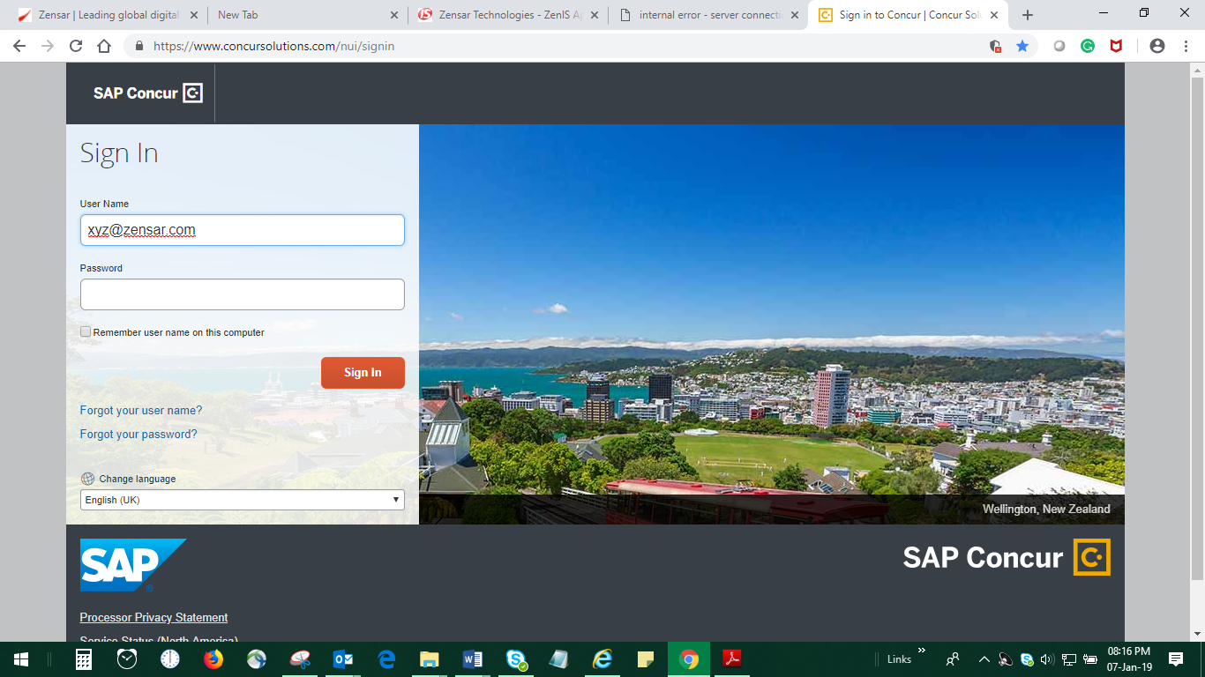

1. Once you sign in, you will see below page.

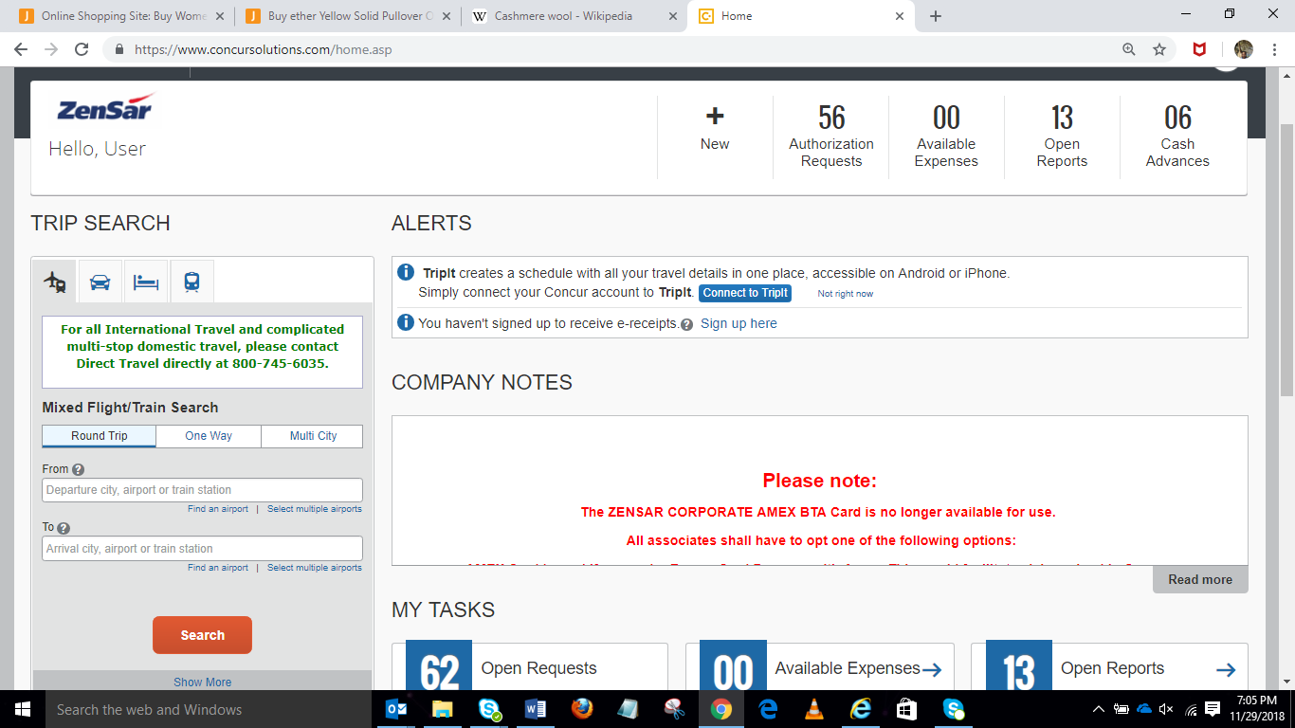**Notes**:

Please contact Zensar Travel Desk for any Travel ,Hotel or Cab Booking issues. For application access issue contact 24x7 Concur customer care number.

Login to SAP Concur using your Zensar’s email address as your user name .

* Password is case sensitive.
* This password is one which you had set for concur and not your zenlounge password
* If any assistance please write to [**concur.support@zensar.com**](mailto:concur.support@zensar.com)

The concerned team will respond back to you for the same once they locate the issue.

Retrieving and Changing your Password

If you have forgotten your password, you can request to receive it in an email.

**To retrieve your password**

1. On the **Login** page, click the **Forgot your** **password?** link.

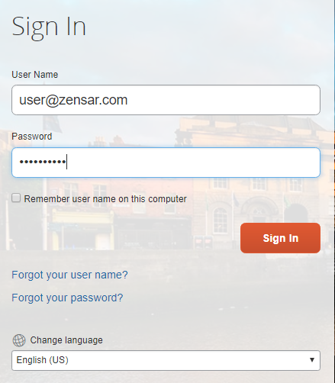

1. Select if you want an email with a password hint, or if you want an email with a link to reset your password, and then click **Submit**.

|  |  |
| --- | --- |
|  |  |

**To change your password**

1. After you log in, in the upper right corner of the page, click **Profile**, and then click **Profile Settings**.

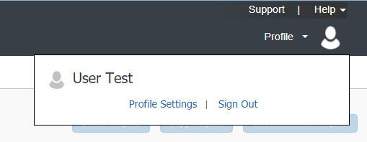

1. On the **Profile Options** page, click **Change** **Password**.

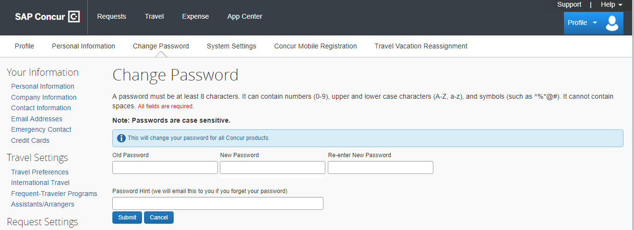

1. Enter current and new password and confirm.

Note that your password must be at least seven characters with at least one number and one letter.

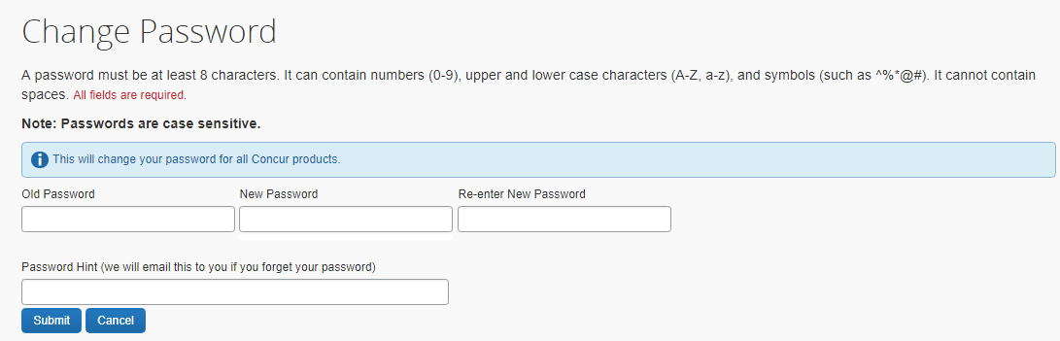

1. To act as a reminder, enter a hint for the password, and then click **Submit**.Exploring the SAP Concur Home Page

The Concur Travel and Expense home page contains the following sections.

**Note:** To return to the home page from any other page, click the SAP Concur logo on the top left of the screen.

Travel and Expense

You will see these sections on your home page.

|  |  |
| --- | --- |
| **Section** | **Description** |
| Trip Search | provides search option to book a trip with any or all of the following:  **Flight:** Use to book a flight.  **Hotel** or **Rail:** Use to book hotels or trains |
| Alerts | Displays informational alerts about travel features. |
| Company Notes | Content is provided by your company administrator. |
| My Trips | Lists all your upcoming trips. |
| My Tasks | List **Required Approvals, Available Expenses, and Open Reports.** |

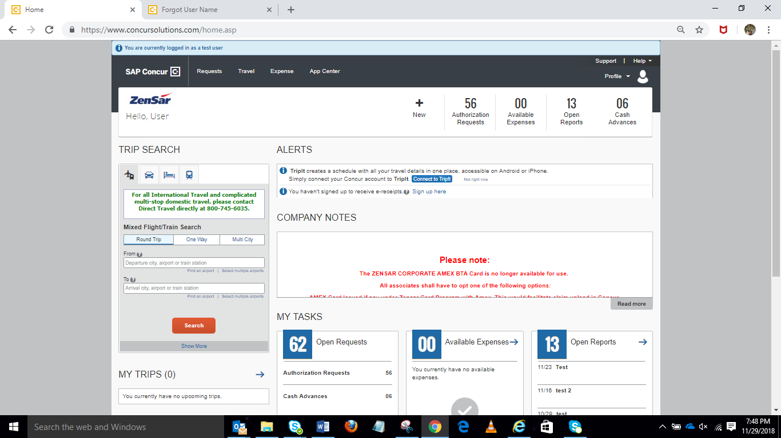

You can make online booking through Concur Platform and complete your transaction using a Platform. Please contact Cusomer Support Service in case of any issue . Please visit company policy for more informations in details

Please contact Zensar Travel Desk for any Travel ,Hotel or Cab Booking issues. For application access issue contact 24x7 Concur customer care number.

Updating Your Profile

You use the **Profile Options** page to customize your user profile. To avoid re-entering personal information again about yourself (phone number, contacts, credit card , Passport and Visa information etc.), complete your profile after logging onto SAP Concur for the first time and update it whenever your information changes.

**Note:** Depending on Zensar's configuration, some of these options might not be available to you. Contact your SAP Concur administrator for more information.

* **Your Information** - Select request information, add or remove delegates, enter email settings, selectapprovers, and add or remove attendees.
* **Travel Settings** - Enter travel preferences, add international travel information, and your Frequent-Traveler programs. You can also add your travel assistants and arrangers.
* **Request Settings** - Select request information, add or remove delegates, enter email settings, selectapprovers, and add or remove attendees.
* **Expense Settings** - Enter expense preferences, add bank information and company card information. Youcan also enter expense delegates and approvers.
* **Invoice Settings** –Enter invoice preferences, add invoice delegates and approvers.
* **Other Settings** – Provides settings such as E-Receipts Activation and Concur Mobile Registration that you can set or update.

**To access Profile page**

1. Click **Profile > Profile Settings**.
2. On the **Profile Options** page, review information, and select the appropriate links to update profile information.

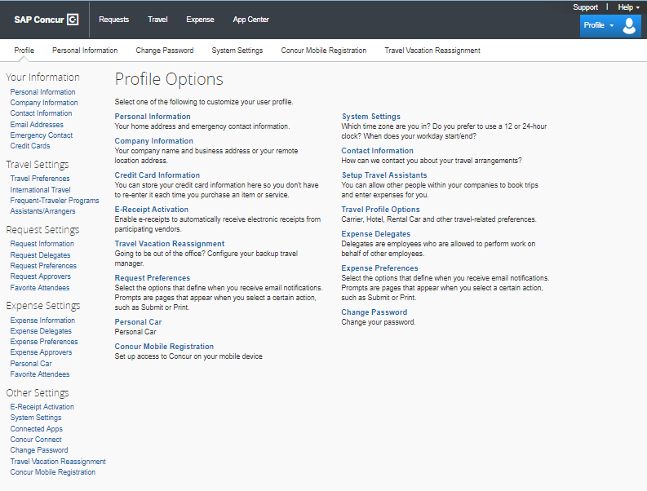

Acting as a Request Delegate/Expense Delegate

If you have been assigned to work as a delegate, your delegator will define which tasks you can complete, such as preparing and submitting reports.

**To work as a Request delegate**

1. Click **Profile** > Request Setting 🡪 [Request Delegates](https://www.concursolutions.com/expense/profile/delegates.asp?pc=REQ) or Expense Setting 🡪 [Expense Delegates](https://www.concursolutions.com/expense/profile/delegates.asp?pc=REQ)
2. Select the appropriate user’s name and Save
3. To select a different user, follow the same steps but select a different name.
4. You can also delegate

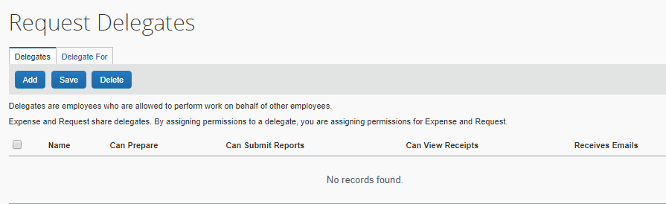

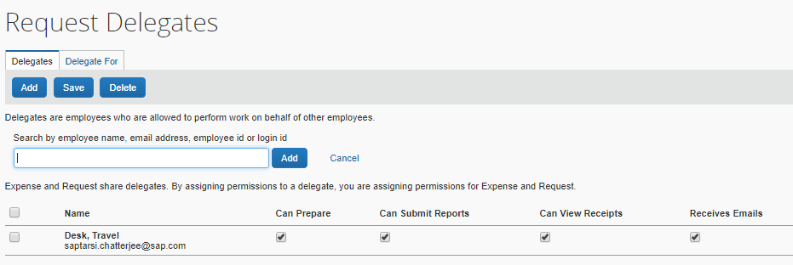

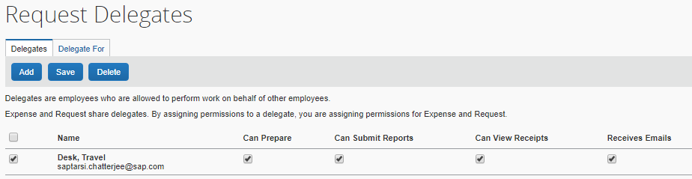

v

**Note**: The **Profile** menu now displays **Acting as** and shows the name you just selected.

You are now officially working on behalf of that person. Complete the normal processes of creating reports, printing, etc.

Initiate Concur Travel Request

Associate raise the travel request using “Requests module” in Concur.

**Select New Request to raise a travel request** 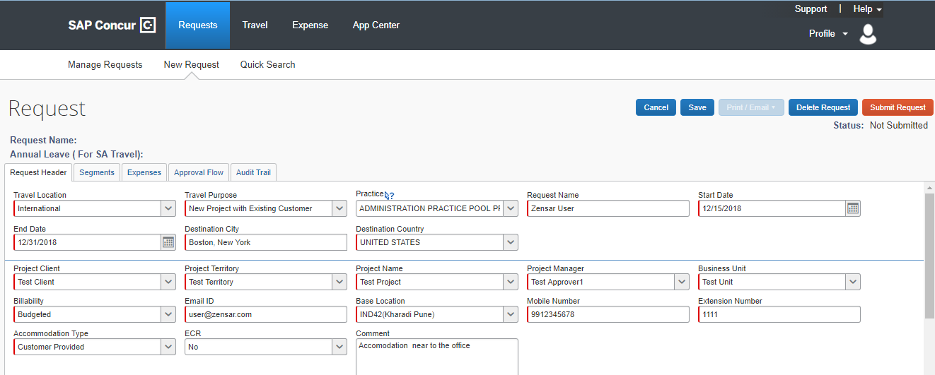

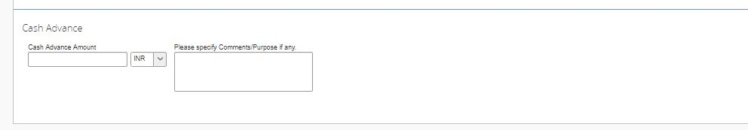

Note : All the Fields mark red are mandatory fields

Click on the Segments Tab to add Passport, Visa, Air, Rail, Bus, Cab , Hotel and Cab Booking

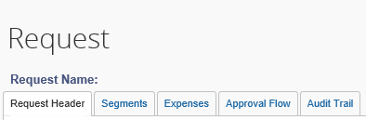

**Request**

You will see these sections under Request page.

|  |  |
| --- | --- |
| **Section** | **Description** |
| Request Header | Provides the information for your travel and Cash advance and expense request for trip with any or all of the following:  **Flight** (Domestic or International) .  **Rail or Bus** (Domestic or International)  **Hotel** (Domestic or International) |
| Segments | Informational alerts about Travel features like Air,Train,Car Rental, Bus tickets, Hotel accommodation, family and guest travel details. |
| Expenses | All expenses related to travel request |
| Approval Flow | Lists your Request Approval Status. |
| Audit Trail | Lists all the actions for a request. |

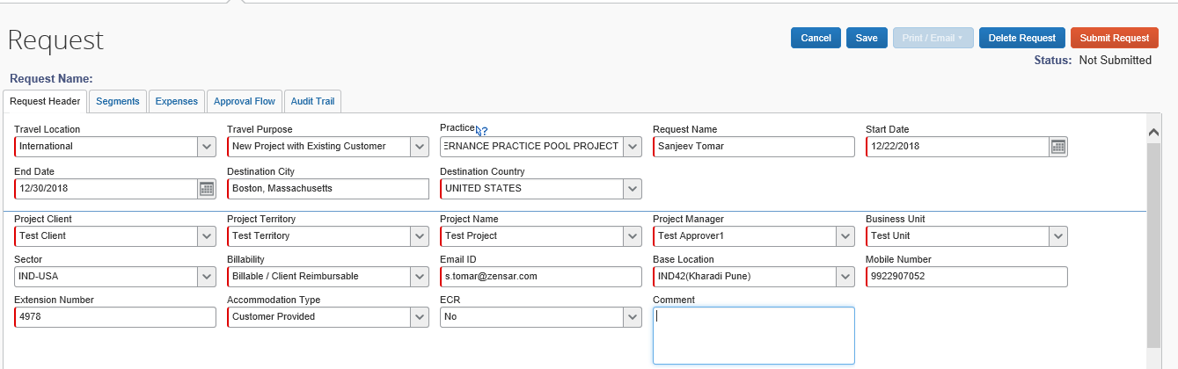

User is expected to fill any justification/brief explanation/reference for his travel in “Comment Box” above, which could help all the Approvers to identify and approve the user’s request.

Cash Advance:



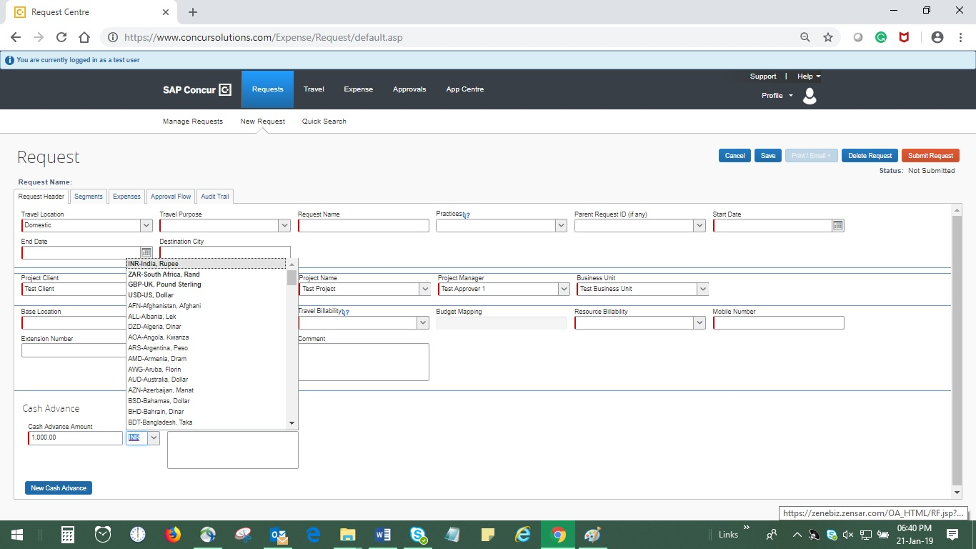

User could raise cash advance /forex request from “Cash Advance” tab.

This is not a compulsory field and if user is not in requirement of any cash advance /forex he may leave it blank and move further with the request.

This could be availed in multiple currencies at the same time in same request.

**Other Segment Icons for travel details:**

Click on Save button to save the request or click on Segments tab to generate your request Id and go to the Segments tab to fill the Travel details.

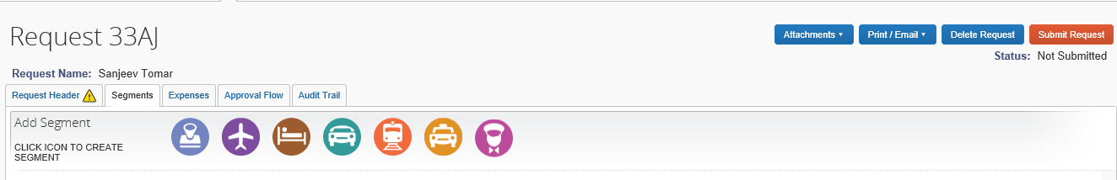

Passport,Visa and other details

Bus

Car Rental

Air Ticket



Guest

Dependents/Family

Train Ticket

Hotel Reservation

User is expected to fill all relevant segments before “Submit Request” to provide details of his travel.Leaving them empty is taken as “not required” by concerned travel team.

If User has not updated his Passport and Visa details in “Personal Information” under “My Profile”, such details do need to be filled in “Passport,Visa and Other details”.

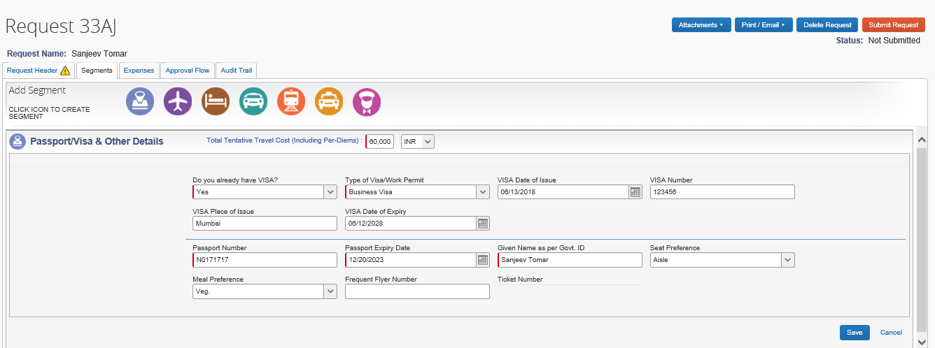

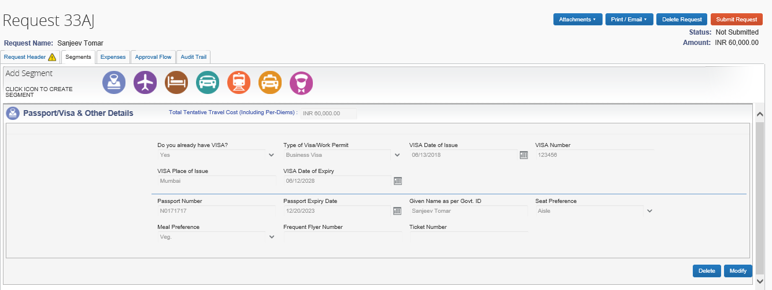

User can correct or delete the information on the same page by clicking **Delete** or M**odify** button at right hand bottom of the Passport and Visa Screen.

**\* Note : For the International Travel request , Associates are requested to update passport and Visa information to their profile.**

**This is a one time activity for associates.**

Air Ticket

User can fill Round trip or Oneway or Multiple-Segment ticket request here

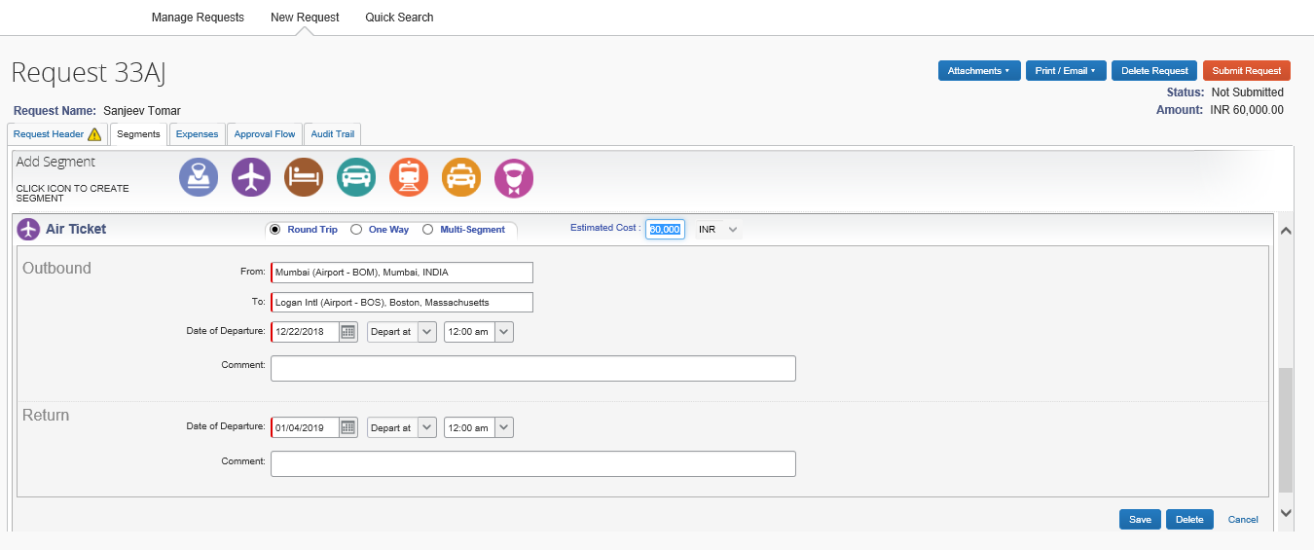

Hotel Booking

To book hotel reservations with/without booking flight, use the Hotel  Search tab

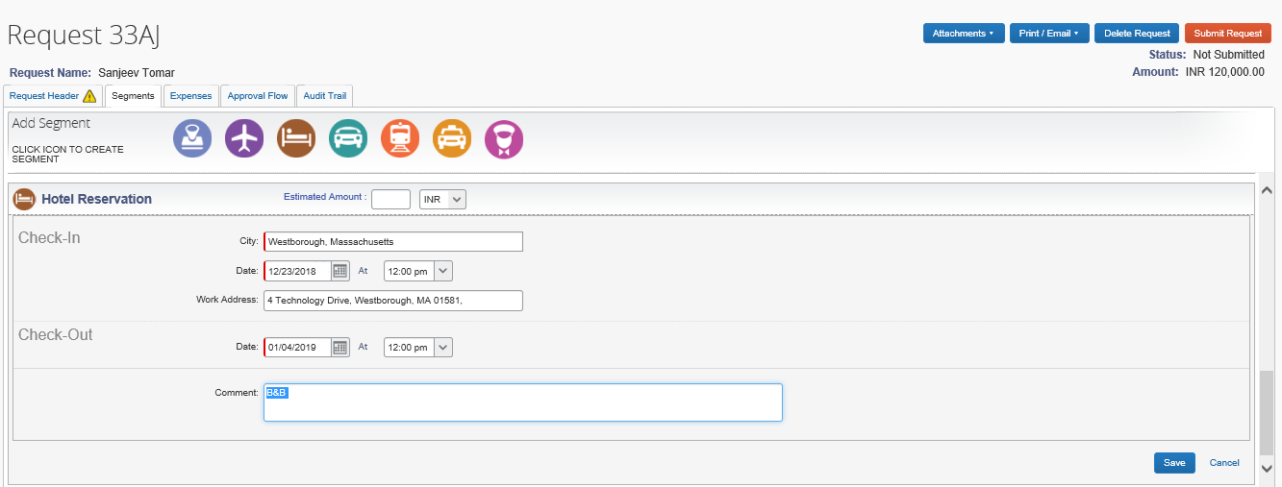

Railway Ticket

The segments section under request shows tabs for rail booking , if that is your preferred mode of travel.

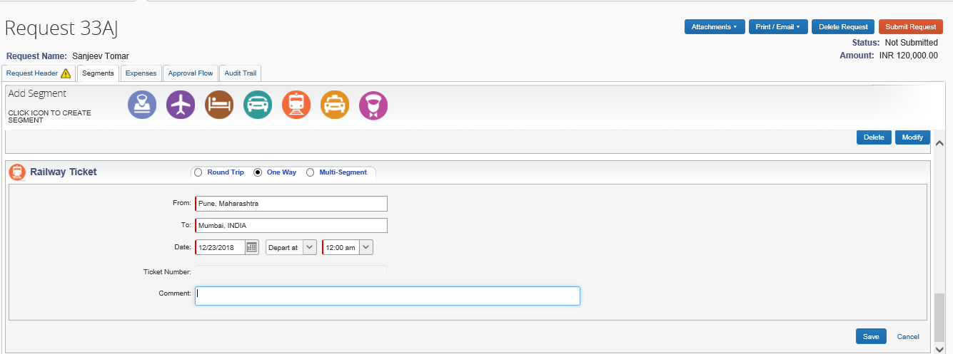

Initiate Cab Booking / Car Rental

Associate could raise Car rental request as applicable to his grade from this icon

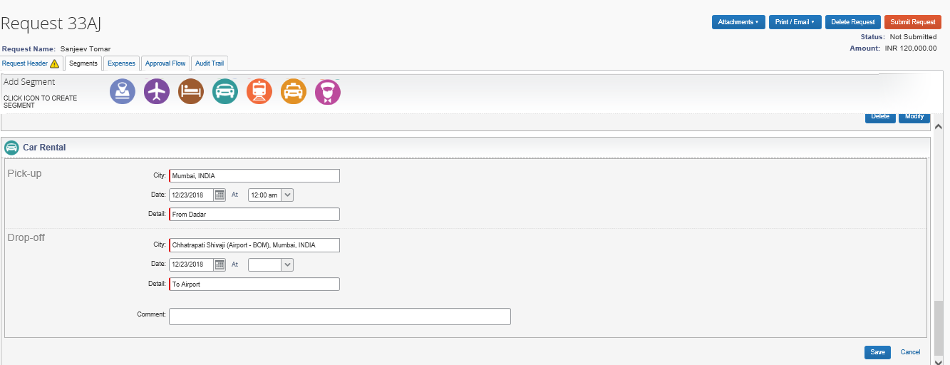

Dependents/family or Guest booking

Associate can raise request for dependents or accompanied guest request through this tabs

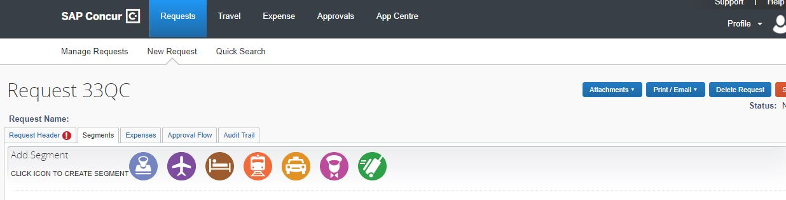

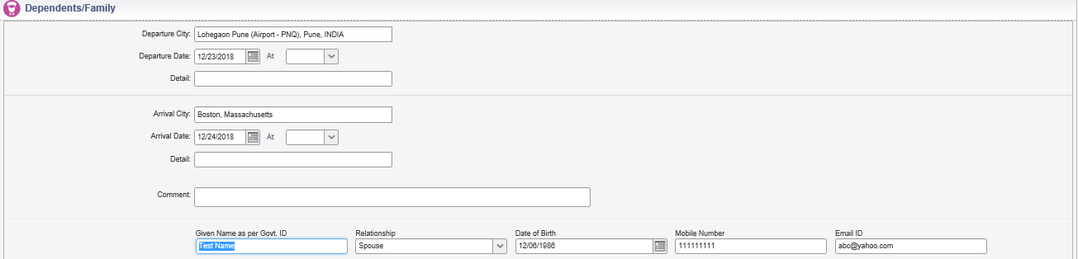

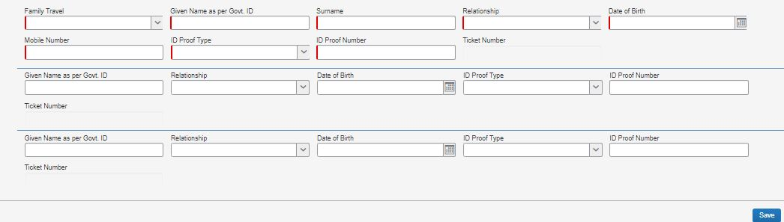

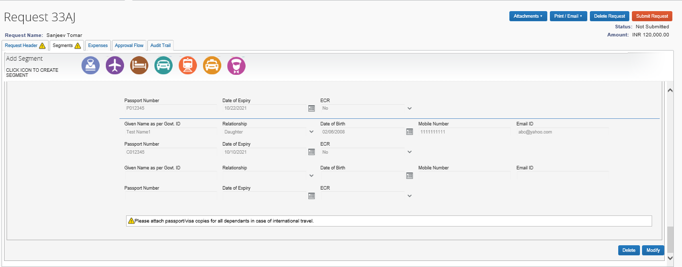

**For Guests:**

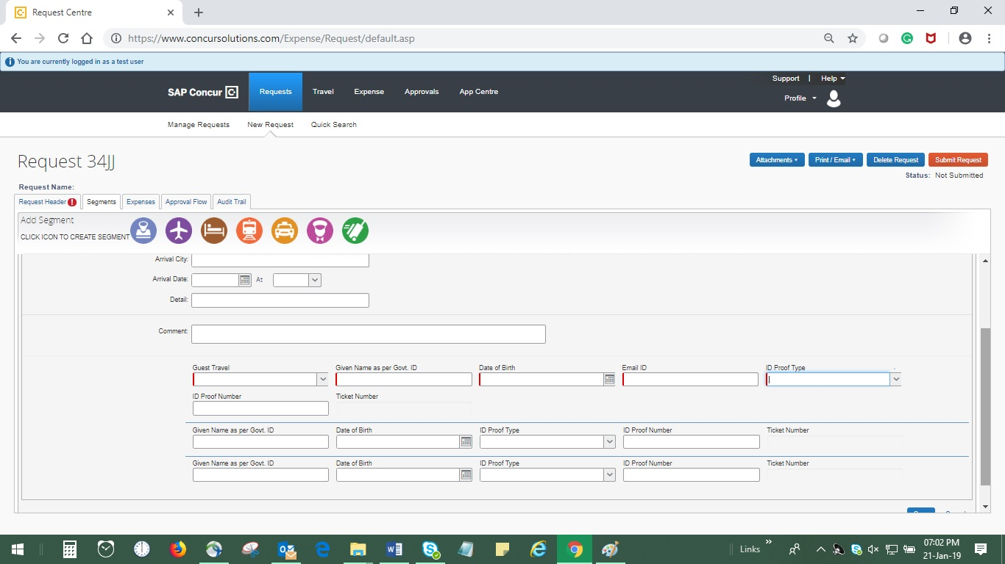

Approver Workflow

Associate can check the status of Approval at any stage on this tab.

In case user is not able to find the concerned Project Manager/BU head name appearing in below tabs.He should check his Project directory status and take requisitive steps to get the same updated through his manager.

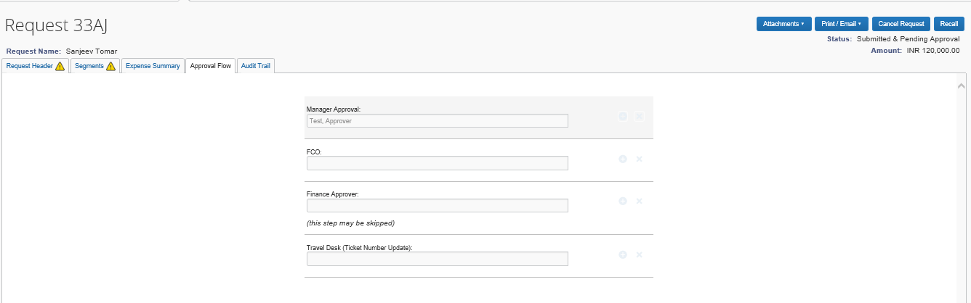

Audit Trail

An audit track for all the actions on an request made could be seen in this tab

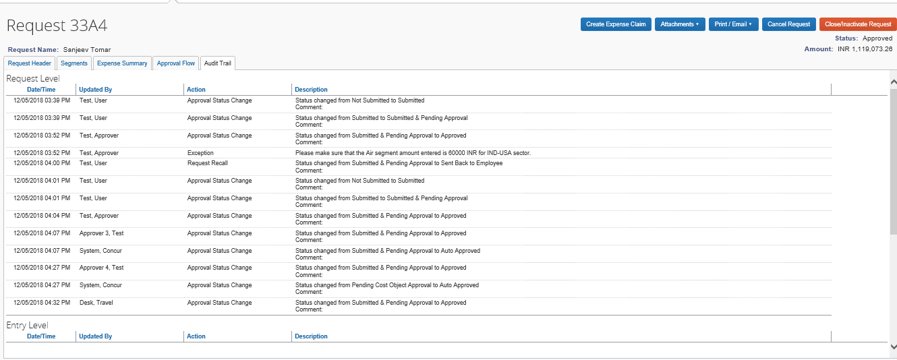

Manager Approval Screen

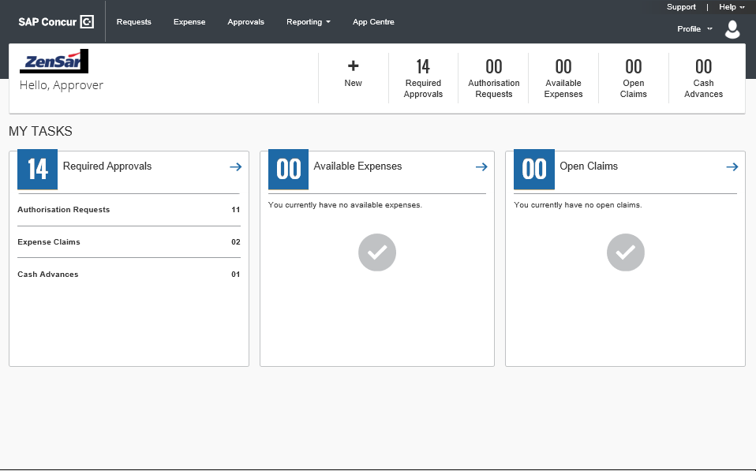

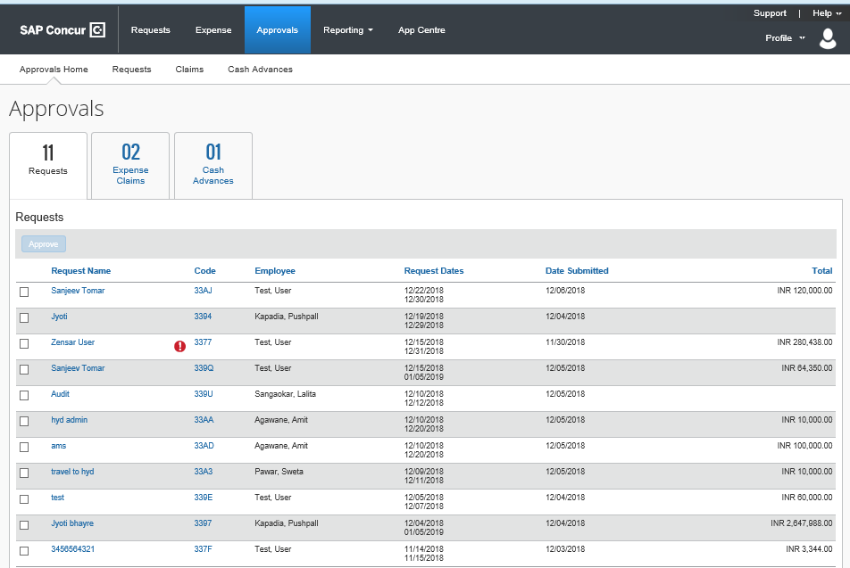

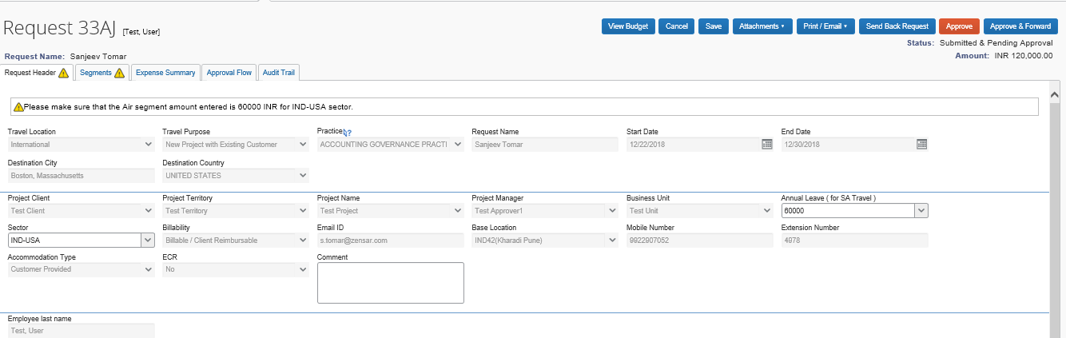

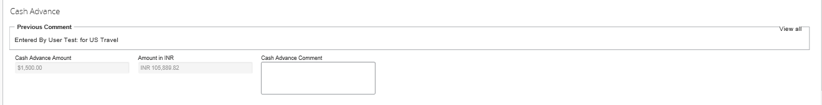

Manager could view the budget status through this tab



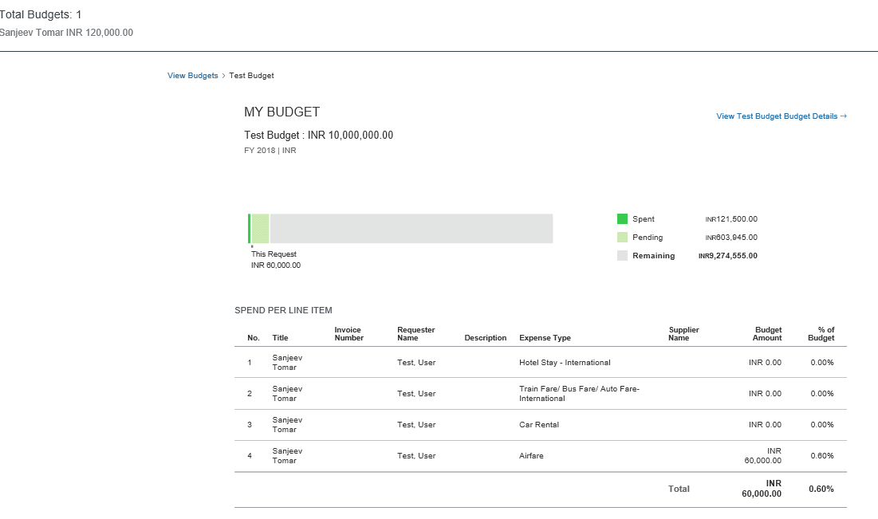

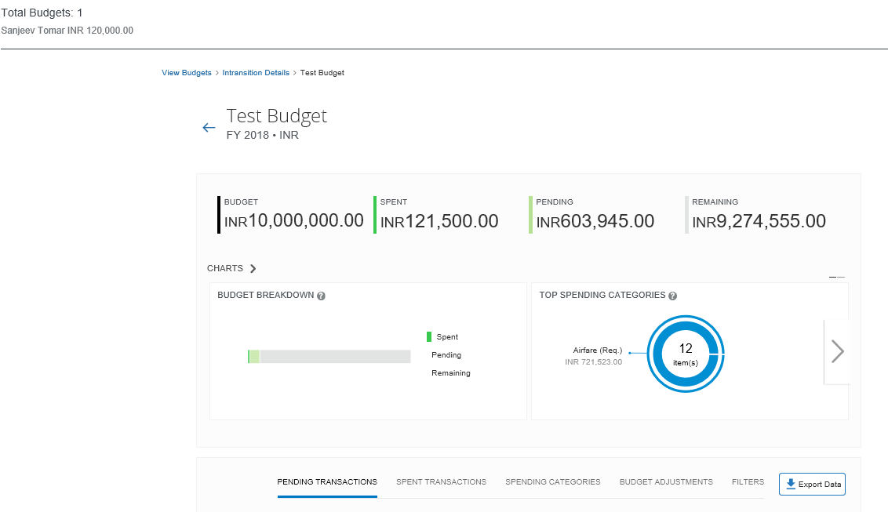

Creating an Expense Report

**To create an expense report against your Request**

1. On the Request Home Page.
2. Concur Requests 🡪 Manage Request🡪Action click on Expense. Expense button will be enabled once your Travel request completed by Travel desk team.

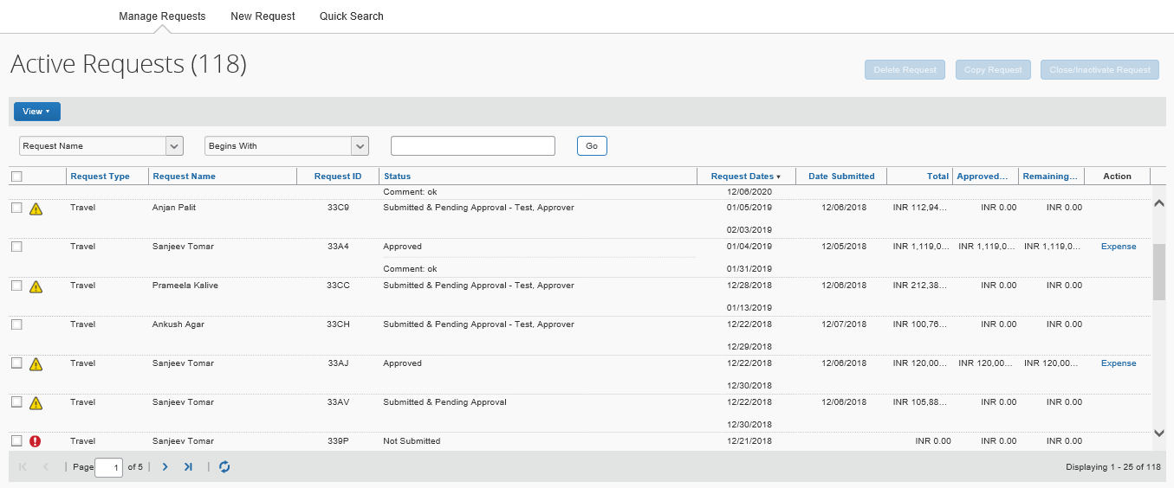

**To create an expense report**

1. On the Concur Expense home page, place your mouse pointer over **New** on the Quick Task Bar, and then click **Start a Report**.

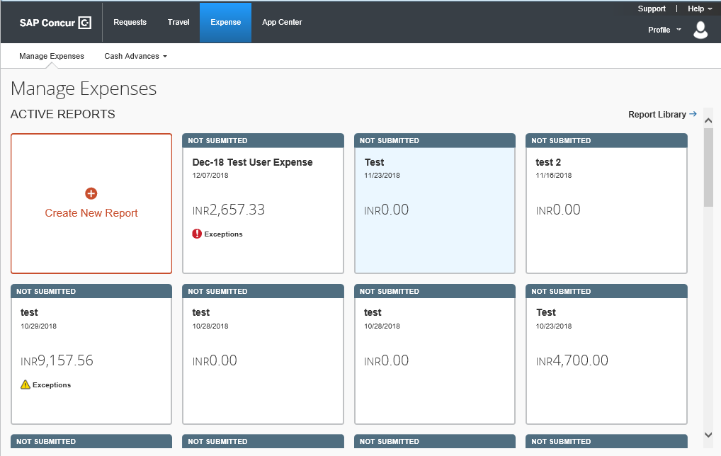

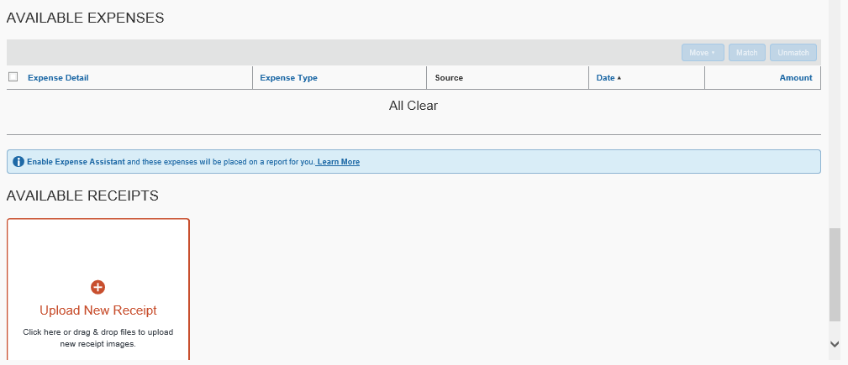

**Report Header**

1. On the **Create a New Expense Report** page, complete all required fields (indicated with a red icon) and the optional fields and then click **Next**.

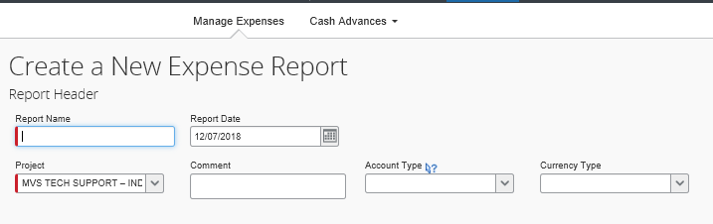



1. Click your Cash Advance amount to want to Link with your **Expense** Claim

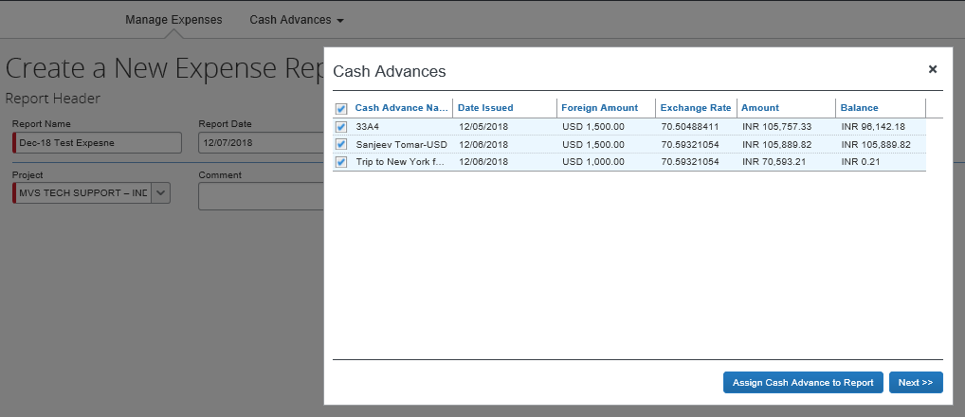

1. Click New Expense to create a new expense or select one from the Expense Type list.
2. After you select the expense type, the Expense Type fields automatically populate.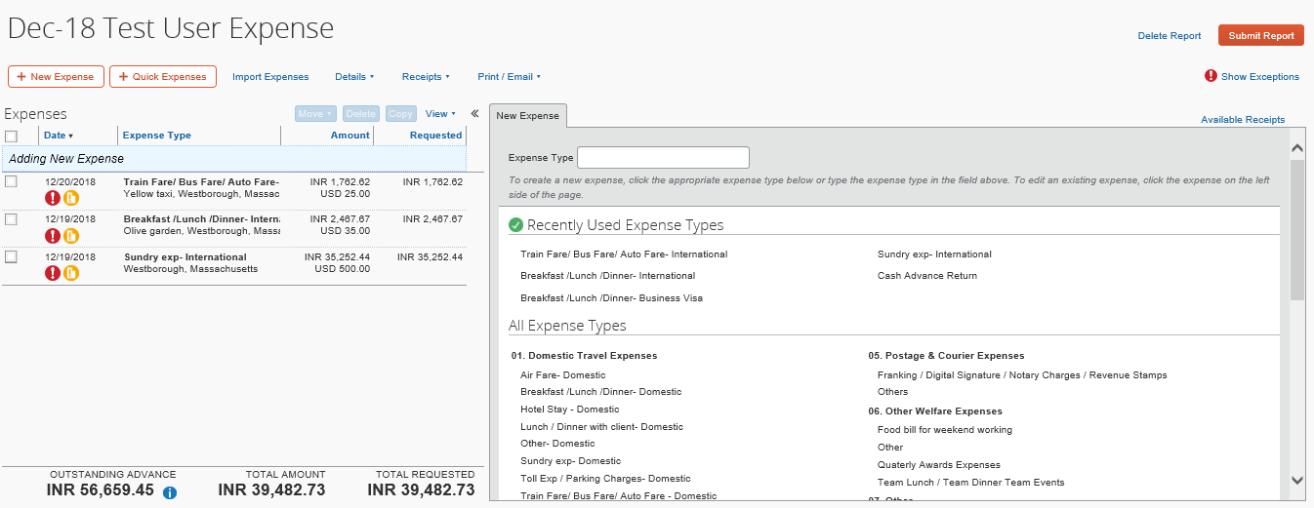
3. Complete all required fields and the optional fields, and then click Save.

**Note**: To delete an unsubmitted report, click **Delete Report**.

1. Click Import Expenses, and then select Available Expenses.
2. Select the check box(es) for the expense you want for add to this report, and then click Move.
3. From the Expense tab, complete the required and optional fields, as needed (required fields are indicated with a red asterisk).

**Uploading receipts**

Available Receipts work with the Concur Imaging Service to provide receipt images that the user can either email or upload images to, and then use to attach images at the line item expense entry level (only). Images in supported format are uploaded using a SAP Concur-verified email address provided by the user during signup, and these images are then available to that user (only) for the purpose of attaching to report expense entries.

**To attach a receipt image to an expense entry using Available Receipts**

1. Select an entry to open it in **Details** view.
2. Click **Attach Receipt Image**.
3. Select the receipt image you want to attach, and then click **Attach.**
4. The receipt image is attached to the expense entry and displays on the right side of the screen.

**Note:** You can **Detach** or **Append** the image from the receipt pane.

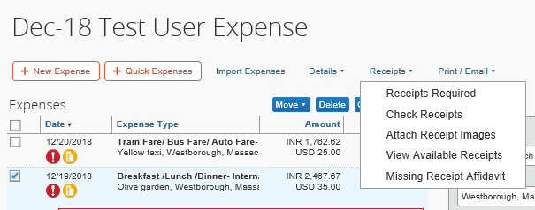

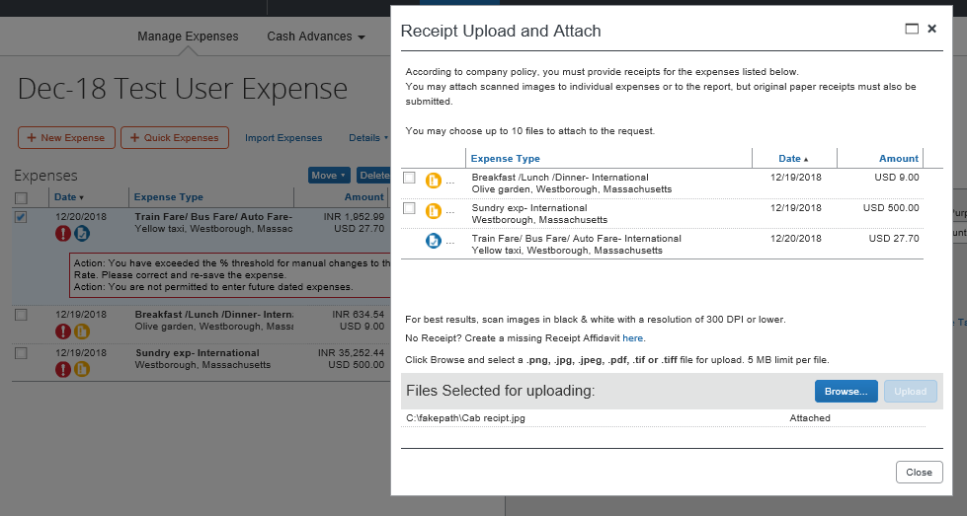

Click **Save Expense**. Click Submit Claim.

Printing and Submitting an Expense Report

When you complete your expense report, you can print it to save a hard copy for your records or to review required receipts.

To preview and print the expense report

1. On the expense report page, click Print/Share, and then select one of the options from the dropdown list. Your company determines the options that are available.

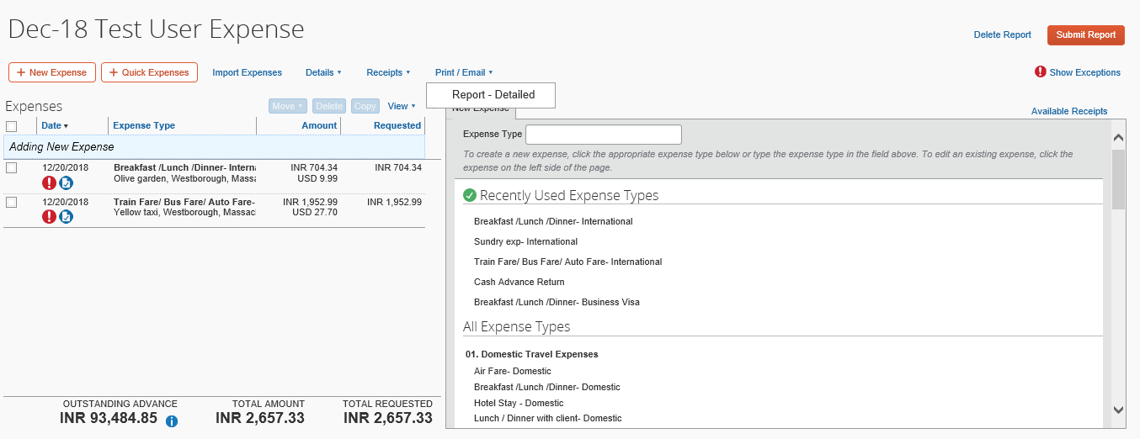

On the Detailed Report screen, review the details, and then click Print.

**To submit your expense report**

1. On the expense report page, click **Submit Report**. The **Report Totals** window appears.
2. Review the information for accuracy, and then click **Submit Report**.
3. The **Report Status** window appears.
4. Click **Close**.

If you cannot successfully submit the report, a message appears describing the report error or alert. Correct the error, or if you require help to complete the task, contact your SAP Concur administrator.

|  |  |
| --- | --- |
|  |  |
| USER SUPPORT DESK INTERNATIONAL TOLL FREE SERVICE (ITFS) for Concur | |
| *Argentina 08002661622* | *Korea 0806530880* |
| *Australia 1800720063* | *Lebanon 01-426-801 + 8558889159* |
| *Austria 0800201924* | *Lithuania 880031857* |
| *Bahrain 80081556* | *Luxembourg 0080026628712 (No Mobile Access)* |
| *Belarus 882003210074* | *Malaysia 1800889892* |
| *Belgium 080081398* | *Mexico 018000835613* |
| *Brazil 08000474956* | *Morocco 002-11-0011 + 8558885257* |
| *Chile 800395121* | *Netherlands 08004500008* |
| *China 4008810215* | *New Zealand 0508330219* |
| *Colombia 018000125408* | *Nicaragua 0018002202279* |
| *Costa Rica 08000320003 (No Mobile Access)* | *Norway 80056023* |
| *Czech Republic 420800050115* | *Pakistan 00 800 01001 + 8558881938* |
| *Denmark 80601104* | *Panama 0018005073006* |
| *Dominican Republic 18007519026* | *Peru 080077159 (No Mobile Access)* |
| *Ecuador 1800000451* | *Philippines (Globe Network) 180089086527* |
| *Egypt 08000009076* | *Philippines (PLDT) 180014410764* |
| *El Salvador 80000000023 (No mobile Access)* | *Poland 800080289* |
| *Finland 0800417462* | *Portugal 800209213* |
| *France 0805541061* | *Russia 8005556412* |
| *Georgia 995706777921* | *Saudi Arabia 8008445983* |
| *Germany 08007236433* | *Singapore 18004155549* |
| *Ghana 233242426062* | *Slovakia 0800135671* |
| *Greece 0080044142579 (No Mobile Access)* | ***South Africa 0800488836*** |
| *Guatemala 8558893036* | *Spain 900816038* |
| *Hong Kong 30774660* | *Sweden 020980778* |
| *Hungary 0680981524* | *Switzerland 0800000339* |
| ***India 0008004402176*** | *Taiwan 0809090172* |
| *Indonesia (PT Telkom) 0078030114523* | *Thailand 18004417137* |
| *Ireland 1800812854* | *The United Arab Emirates (UAE) 80004440584* |
| *Italy 800906973* | *Trinidad & Tobago 18002037126* |
| *Japan 0120838121* | *Turkey 00800448828708* |
| *Kazakhstan 88005556975* | *Ukraine 0800502952* |

**India:** 0008004402176

**South Africa**: 0800488836

**United States and Canada:** 1-866-793-4040

**United Kingdom**: 08003898758

*Note: If the country you are calling from, is not on the toll free number list, please contact Concur  at one of the toll numbers listed at the bottom*

**USA Toll Numbers:**

English - 952-947-1962, Spanish – 952-947-1965, German – 952-947-1960

**United Kingdom Toll Number for EMEA:** +44 2037 936933

Or write for assistance on

*Concur.support@zensar.com*

*****